Close SmartDashboard
建立user
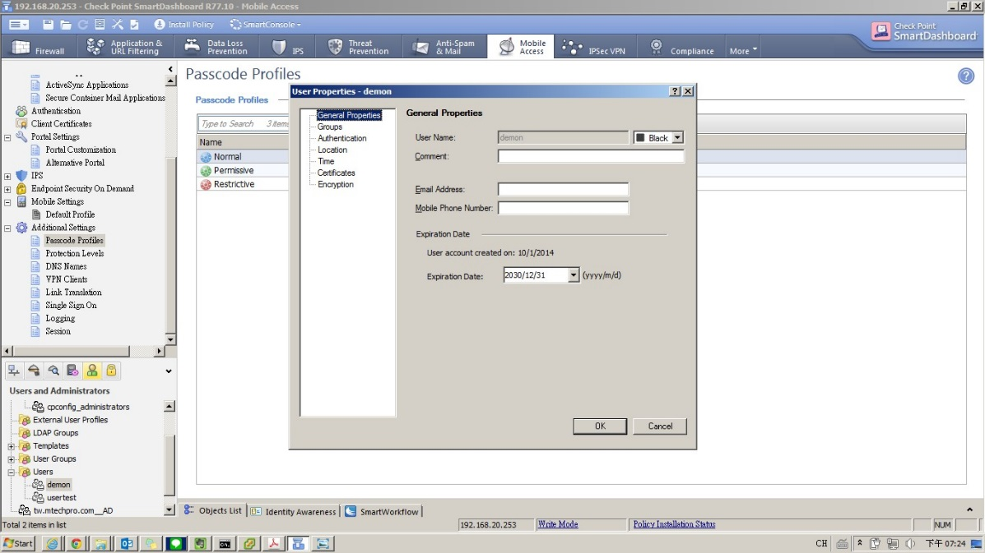
Password use undefened
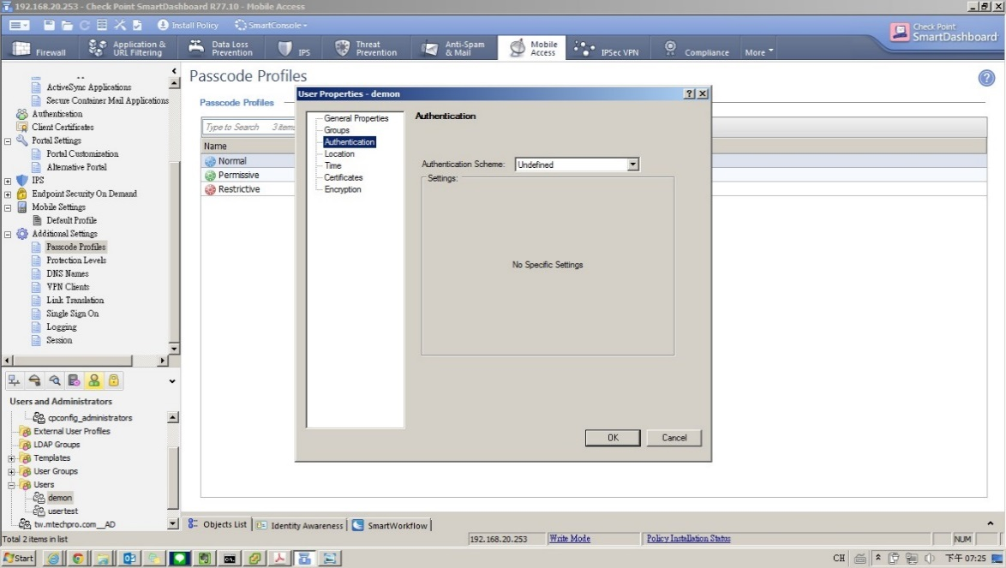
產生憑證 (P.12)
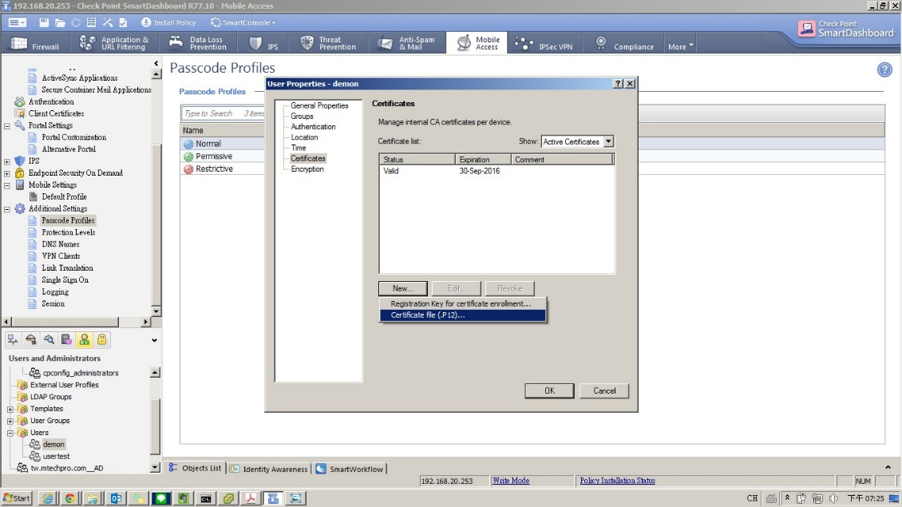
檢視憑證
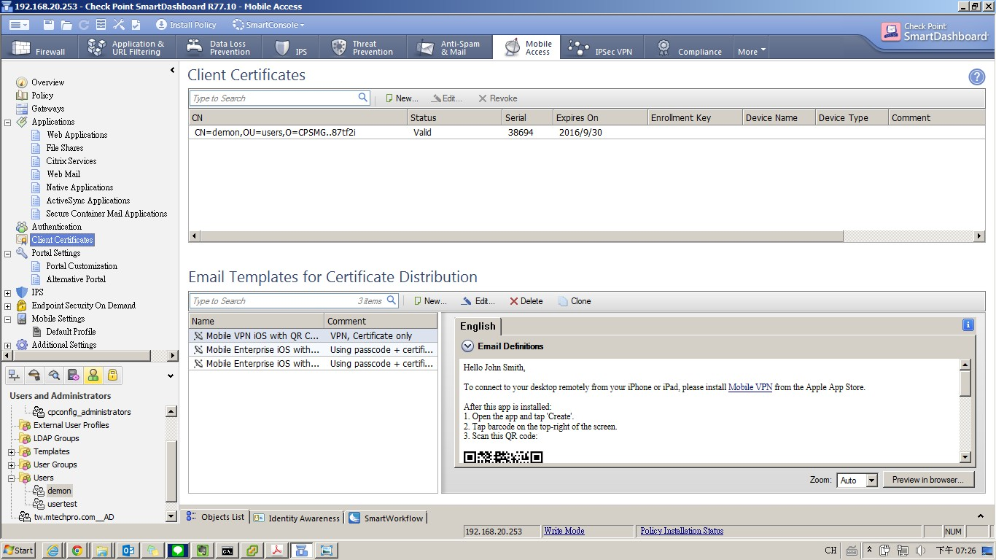
Open GuiDBedit.exe (C:\Program Files (x86)\CheckPoint\SmartConsole\R77.10\PROGRAM)
找到gw相關物件，並尋找關件字” realm_blade_entry ”，再找到ssl_vpn
Modify “Element Index 1” refer below screenshot，
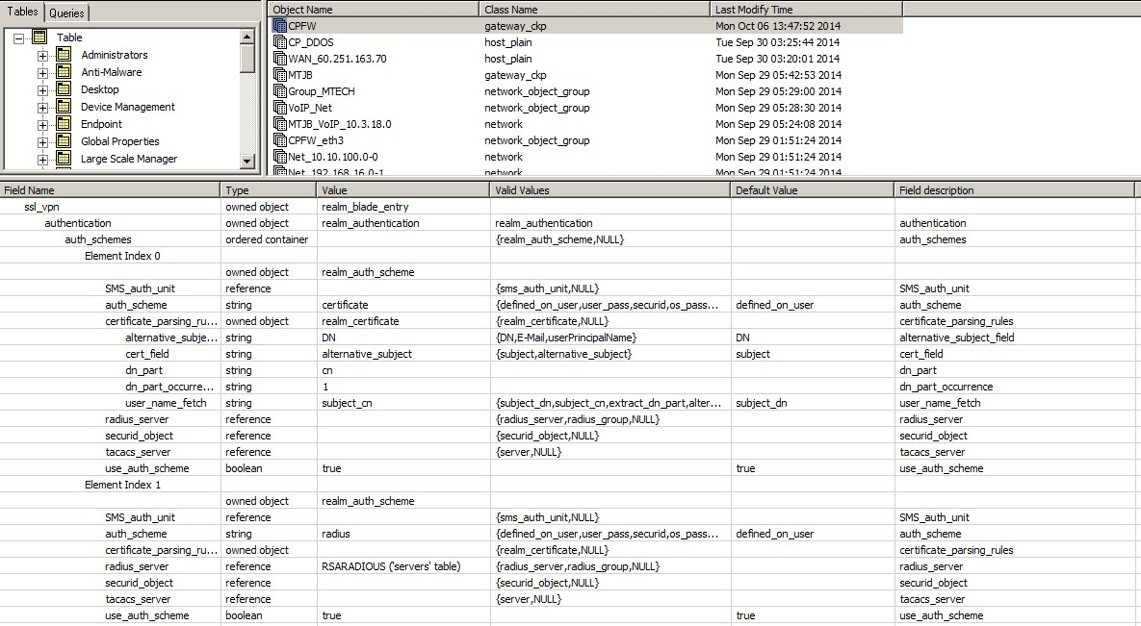

Modify “Element Index 1” & “directory” refer below screenshot
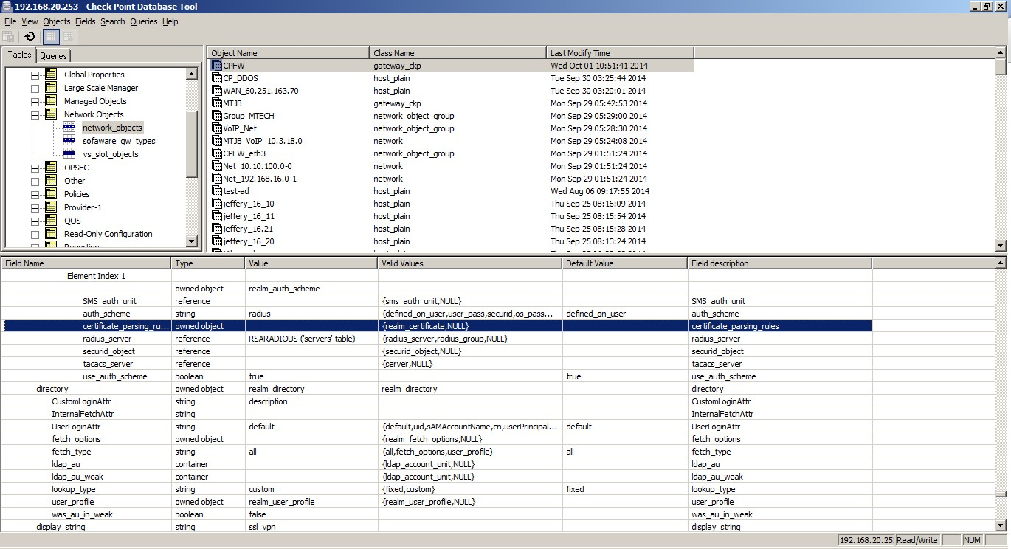

Save config & close CheckPoint Database tool
Enable smartdashboard install policy

