Using SmertMove for Juniper to Checkpoint Gaia-R80.10
Existing Firewall
H/W : Juniper SRX 3400 ,
firmware = JUNOS 12.1X46-D40.2 built 2015-09-26
To be Migrate on Checkpoint
H/W : Open Server
OS : Gaia R80.10

Followed below Procedure :

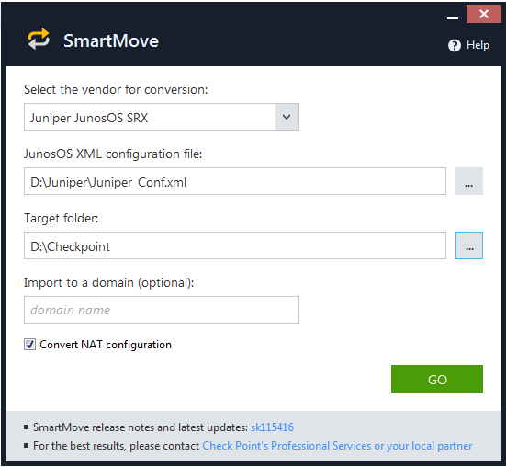

Encounter an error related to SRX version
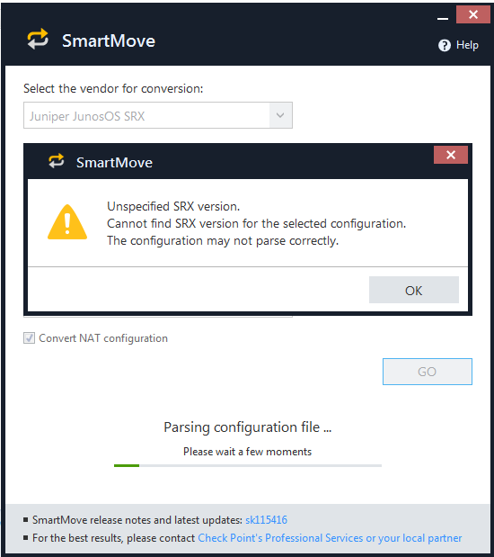

I ignored the error any continued the process
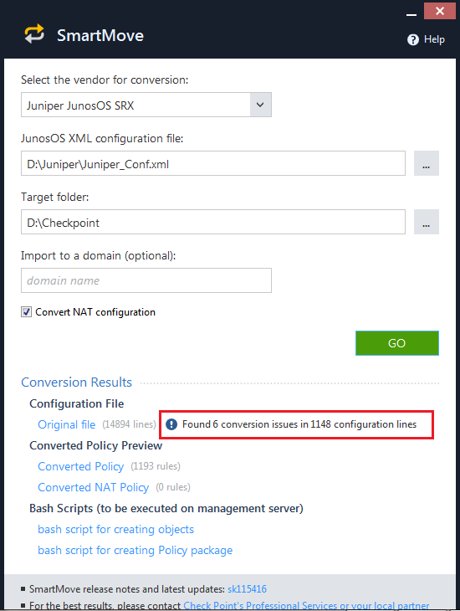
Got error into 1148 lines and created only following two script files :
Juniper_Conf_objects.sh
Juniper_Conf_policy.sh

Exported these script file to Management Server Using winscp tool.

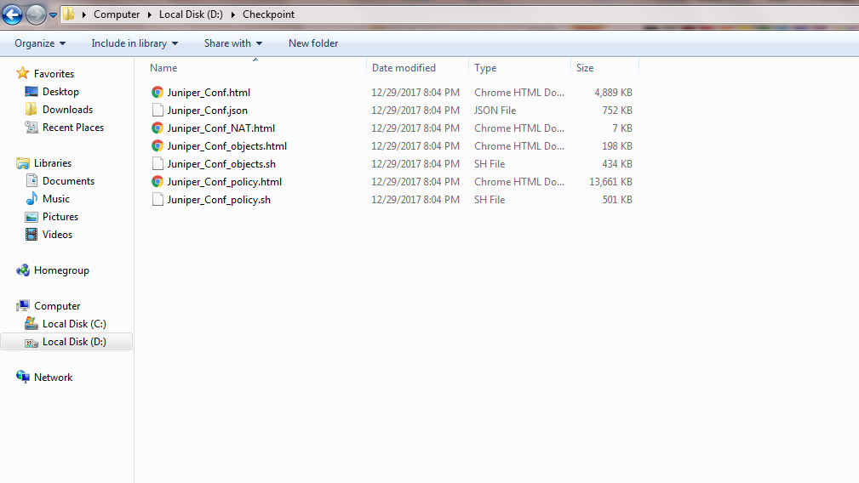

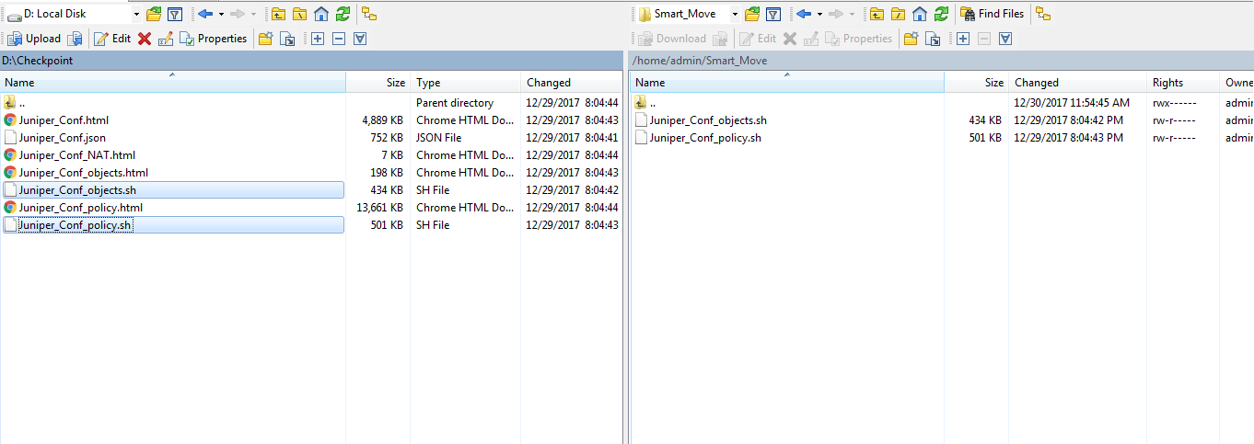

Then made these scripts to linux compatible and executed these scripts as shown below :
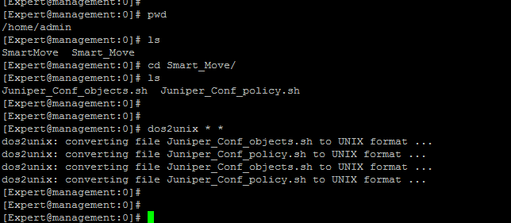
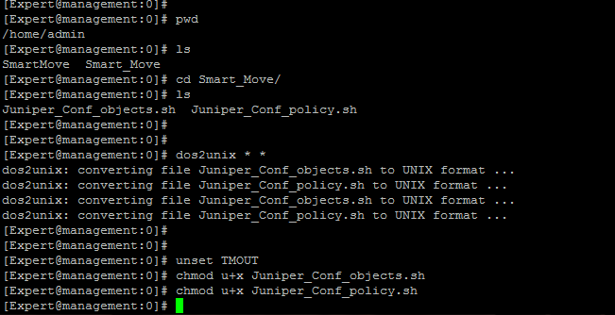

Once executed the first script, encounters below error :

